TRANSFORM TO PERFORM COACHING
THE REWIRE
METHOD™
For the ones who built it all, and still cannot switch off.
NICKY ANSTEY
Award Winning, International Mindset Rewiring Specialist for Leaders · Master NLP Coach - Executive Performance Coach · Nutritionist

WHO I WORK WITH
You built the business. Now the business is running you.
You're the one everyone comes to. The calm one. The one who gets it done, who holds the team together, who never drops the ball, even when three balls are already on fire and a fourth one has just been thrown at you.
From the outside, you look like you've made it. The revenue is there. The team is growing. People ask you how you do it.
From the inside, it's different. You're tired in a way sleep doesn't fix. You're carrying a version of yourself that has to be switched on, always available, never the one who needs help. You say yes when every part of you wants to say no. You check your own work eleven times because good enough has never once felt like enough. And somewhere in the last few years, the enjoyment you built all of this for quietly left the building.

You are not weak. You are not failing. You are not in the wrong life.
You are wired. And wiring can be changed.

I work with business owners, founders and senior executives who are strong, capable and successful, and who are also running on empty behind a door marked 'fine'.

WHERE YOU ARE NOW | WHERE WE TAKE YOU
Extreme pressure that never switches off | Calm, clear control of your own state
Saying yes to everything, resenting it quietly | Boundaries that hold, without the guilt
Second-guessing decisions you are qualified to make | Trusting your own judgement again
Success that looks right but does not feel like anything | A life that feels as good as it looks
Running the business in your head at 3am | Regaining your time, your energy, your sleep
Waiting for someone to work out you are not that good | Knowing, at a neurological level, that you are

WHAT'S CAPPING YOUR GROWTH
What got you here won't get you there
The traits that built your success are the same traits now limiting it. Perfectionism. People-pleasing. Imposter syndrome. I call this the curse of the strong: the very strength that took you from nothing to something starts, unchecked, to strangle you at the next level.

Perfectionism
The standard that once made your work exceptional now means nothing is ever finished, delegation feels dangerous, and rest feels like slacking off.

People-pleasing
The instinct that built your reputation and your client base now means your calendar belongs to everyone but you, and your team makes fewer decisions, because it's always been quicker for you to just do it yourself.

Imposter syndrome
The drive that pushed you to keep proving yourself now means every win gets explained away as luck or timing or other people, while every near miss confirms what you've secretly suspected all along.

These are not personality flaws. They are old wiring, laid down long before you built any of this, and never rewired. And the higher you climb, the more expensive that wiring gets.

WHY REWIRE
Why REWIRE, and not just coaching, or just therapy
Business coaching sharpens your strategy. Mindset coaching gives you a better story to tell yourself. Therapy and counselling help you understand where a pattern came from. All of it useful. None of it, on its own, rewires the pattern at the root.
Most of my clients arrive having already tried one, or all, of the above. The strategy got sharper but the pressure behind it never moved. The language changed but the fear underneath stayed exactly the same shape. They understood the pattern in detail, and were still living inside it.
One method, built from what actually works
I have spent over fifteen years training across neuroscience, neuro-linguistic programming, hypnotherapy, psychotherapy and nutrition, because no single modality was enough on its own to properly fix what I was dealing with, in myself or in my clients. The REWIRE Method combines these into one process that goes straight to the unconscious pattern and changes it there. Not managed. Not better understood. Removed, at the root, permanently.
I have done this with over 1,000 one-to-one clients, and it stays fixed, because we are not out here polishing leaves. We go to the root.
What it does for a business, not just a person
When the leader at the top rewires the pressure, perfectionism and people-pleasing driving their decisions, it moves through the business. Teams report becoming more engaged. Leadership gets more decisive and more consistent. People collaborate with more confidence and less friction, because the person at the top has stopped running on fear and started leading from clarity.

WHY THIS IS PERSONAL
Why this is personal
I did not arrive at this work from a textbook. I arrived at it from the edge of my own life.
I built businesses, and hit burnout doing it. Not the dramatic kind that announces itself with a collapse, but the slow kind, where everything that used to feel easy gets a little harder, year on year, until you no longer recognise the person running on empty in the mirror. I have been a carer for my father through his final months with cancer, and I am a carer for my son now, holding a business together while holding a family together, because that is what people like us do. We just hold it.
None of the standard fixes worked for me. Coping strategies did not touch it. Talking about it did not change it, it just gave me better words for the same old exhaustion. What changed it was learning, properly, at a clinical level, how the brain lays down the patterns that drive our behaviour, and how to go in and rewire them directly.
I trained as a Master NLP Transformation Coach, a Master Hypnotherapist, Business coach using psychotherapy, psychology and as a Registered Nutritionist working alongside medicine, because I wanted every proven tool available to me, not just one. I built the REWIRE Method™ because it is what I needed, and could not find.
I have since used it with more than 1,000 clients. This is not theory I read about. It is a life I rebuilt, one pattern at a time. And now help other high achievers do the same.

HOW IT WORKS
How rewiring actually works
Your brain did not choose perfectionism, people-pleasing or imposter syndrome. It learned them, mostly before the age of ten, as a way of staying safe, staying loved, or staying in control. Those patterns became wired in, and the brain, being efficient, keeps running them long after they have stopped being useful. That is what wiring does. It runs, whether or not it is still serving you.
REWIRE works at the level the pattern was created: the unconscious. Combining neuro-linguistic programming, hypnotherapy and psychotherapeutic technique, I take you underneath the behaviour, to the belief driving it, and change it there. Not manage the symptom for the rest of your life. Change the source of it.
Training, credentials and techniques
- International Executive Psychotherapist
- Master NLP Transformation, Business and Life Coach
- Master Hypnotherapist
- Psychology in Business
- Registered Nutritionist, working alongside medicine
- Rewiring business owners and senior leaders since 2011
- Featured in Men's Health, Wellbeingnews.co.uk and other national news and magazine publications
Proof
Over 1,000 one-to-one clients rewired, with change that stays fixed long term, not a temporary lift that fades by the next quarterly review. Businesses I have worked with report more productive, more engaged teams, and leaders who collaborate with more confidence, more creativity and considerably less friction.

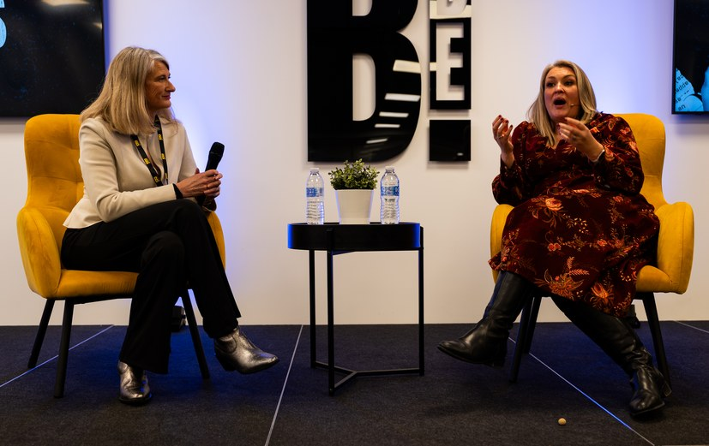 |  |  |  | 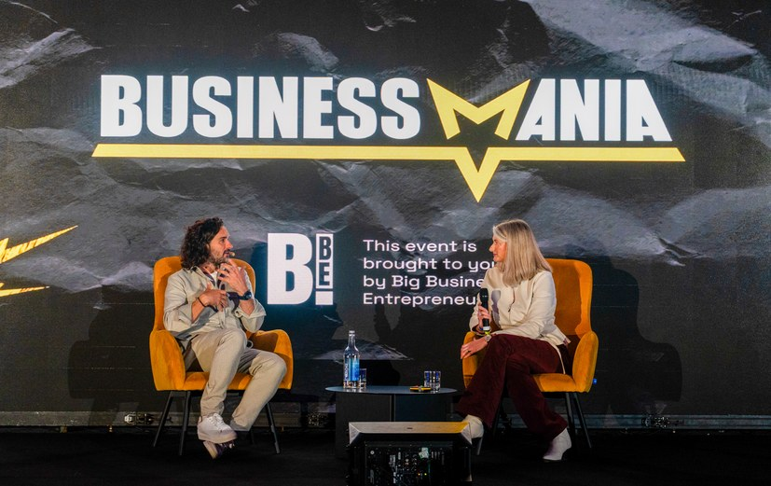
 |  |  |  |  | 
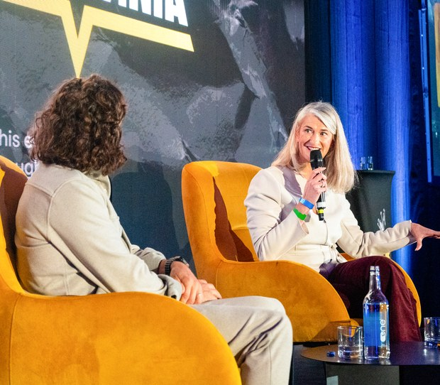 | 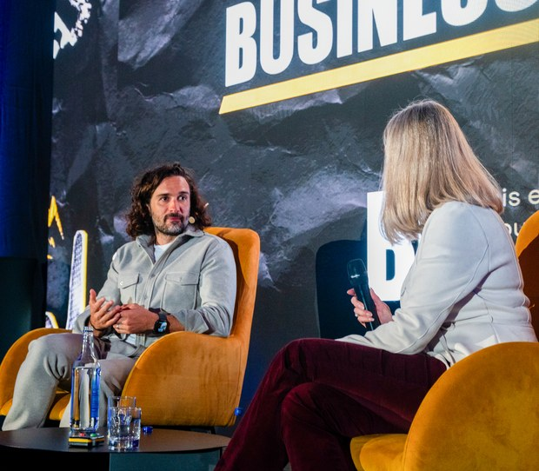 |  | 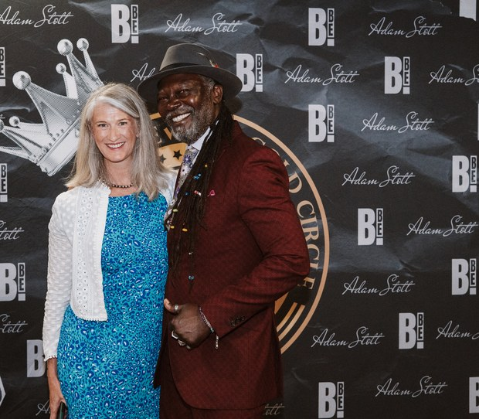 |  | 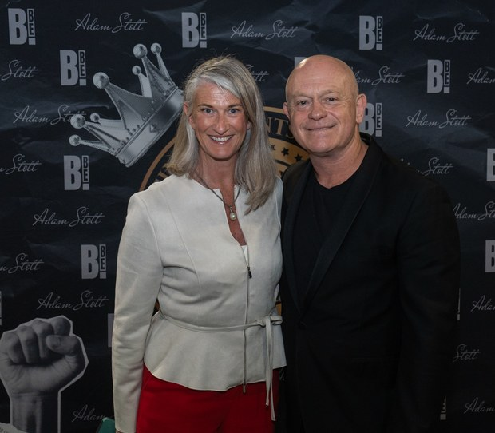
 |  | 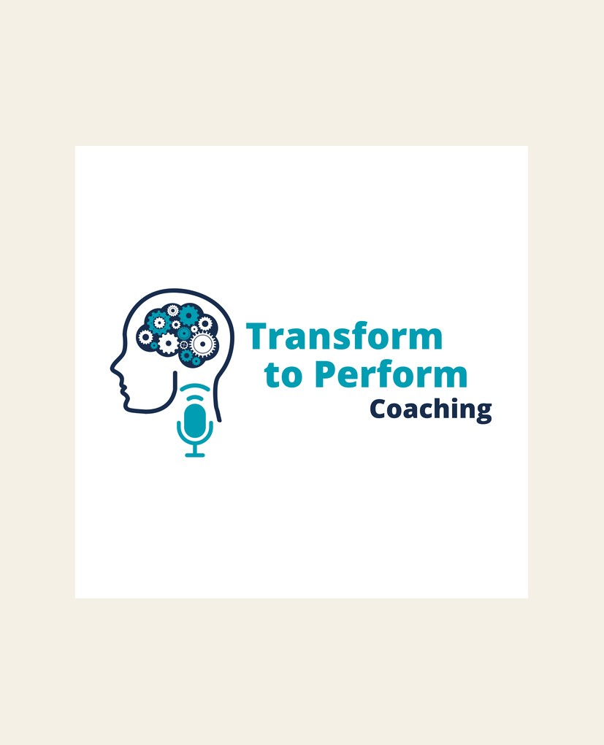 |  | 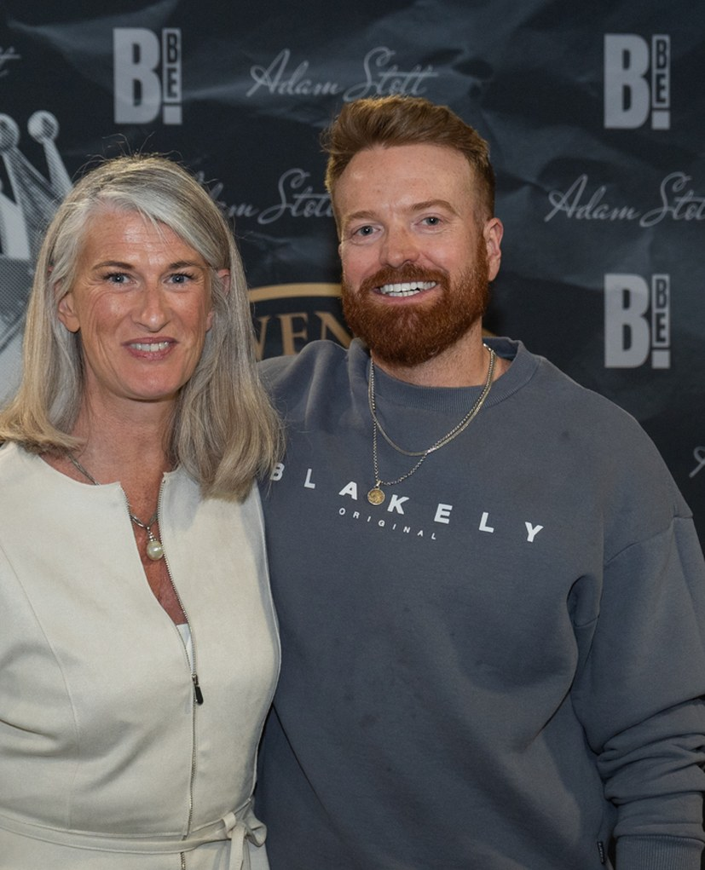
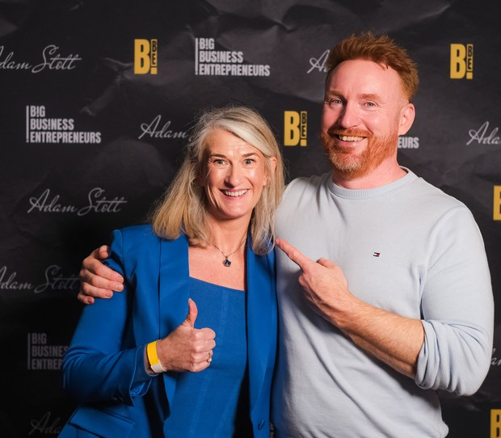 |  |  |  |  | 

WAYS TO WORK WITH ME
How we work together

01 The 8-Week REWIRE 1:1 Programme
For senior leaders and successful business owners ready to go beyond strategy. One-to-one, deep-dive work that rewires the extreme pressure, perfectionism, people-pleasing and imposter syndrome at the root, so you get the edge, and the balance, for growth you actually enjoy.

02 Small Group Work Within Businesses
A blend of group sessions and one-to-one work, built for leadership teams. The same method, the same depth, delivered so a whole team learns to communicate, collaborate and lead with more confidence and less friction, together.

03 Workshops and Keynote Speaking
For corporates who want their leaders thinking, communicating and performing differently. Topics include:
- How to read others and become a super communicator and an unforgettable leader
- How to rewire stress at the foundational level
- How to become more influential
- How to eliminate imposter syndrome
- How the fear of failure stunts success
- And more, tailored to your team

THE MISSION
Regain the joy. Optimise the success.
My mission is to help top leaders regain the joy and the health of their life and their business, so they keep thriving beyond their own expectations and become one of the top 0.1% in their field.
Not by teaching you to cope for longer in survival. By rewiring what is actually in the way to feel true success.

Ready to find out what is actually possible
once the old wiring is gone?

Start with a Performance Reset Call
A focused 30-minute call to look at what's driving the pressure in your business and your life right now, next steps with or without Nicky and if rewiring is right for you.

Book your call: transformtoperformcoaching.com/contact
Website: transformtoperformcoaching.com
Email: nicky@transformtoperformcoaching.com
Follow:
LI: https://www.linkedin.com/in/nickyanstey/
YouTube: https://www.youtube.com/@NickyAnsteyRewireCoach
IG: https://www.instagram.com/nickyansteytransformtoperform/

